Grade Journey for eLearn Ultra (Gradebook)
- For the Resit course site
GB Resit Grades Transfer


This guide explores on how to configure the SYS Grade column for the Resit course site in eLearn Ultra Gradebook.
EMX has done the enhancement to auto-sync the past component mark to eLearn Resit course site.

Here are some important notes for your reference:
- Automatic Grade Column Provisioning
EMX will automatically provision four predefined grade columns in the Resit course site seven days before the Resit exam date.

- Predefined Grade Columns
The following grade columns will be created in your eLearn course. Do not delete or rename the RS and SYS columns in Gradebook:
- SYS-CONTINUOUS ASSESSMENT
- SYS-FINAL ASSESSMENT
- RS-CONTINUOUS ASSESSMENT
- RS-FINAL ASSESSMENT
Once the grade columns are created, it will then automatically sync the marks of past components from EMX to eLearn Resit course site under RS-Columns.

- Automatic Sync of Passed Component Marks
EMX will automatically sync the marks of passed components from EMX to eLearn Resit course site. These marks will appear under the grade columns prefixed with “RS-”.
- Lecturers do not need to create columns and copy marks manually.

- Example Scenario:
If a student passed Continuous Assessment but failed Final Assessment:
- EMX will sync the Continuous Assessment passed marks into “RS-CONTINUOUS ASSESSMENT”.
- The RS-FINAL ASSESSMENT will be empty, so the lecturer can enter the new resit marks directly in eLearn Gradebook.
- Configure the SYS column to map to RS Column:
  - SYS-CONTINUOUS ASSESSMENT map to RS-CONTINUOUS ASSESSMENT
  - SYS-FINAL ASSESSMENT map to RS-FINAL ASSESSMENT

In the Resit course site Gradebook, you'll see four columns automatically created by EMX based on the assessment setup.
In this example, there are two SYS- columns and two RS- columns. Students are only Resiting the Final Assessment.
EMX will automatically sync the past Continuous Assessment marks into the RS Continuous Assessment column in eLearn Ultra Resit course site.
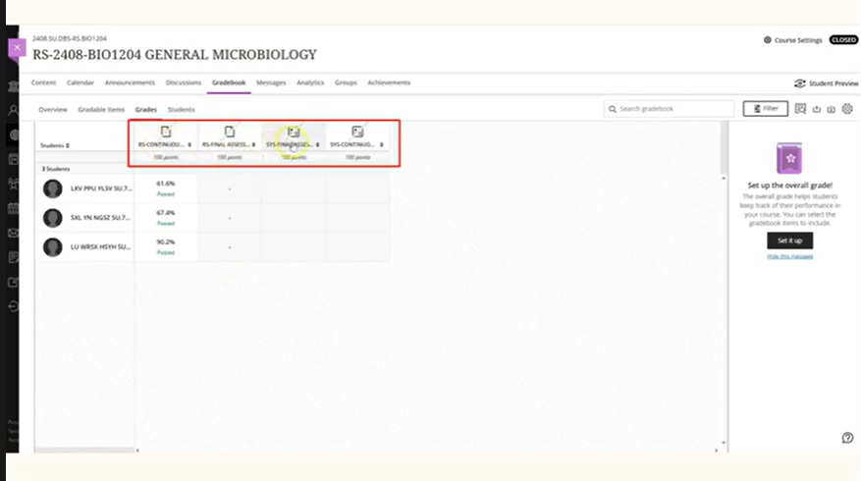
Lecturers are required to key in the new Resit exam marks into the RS Final Assessment column in the Gradebook.
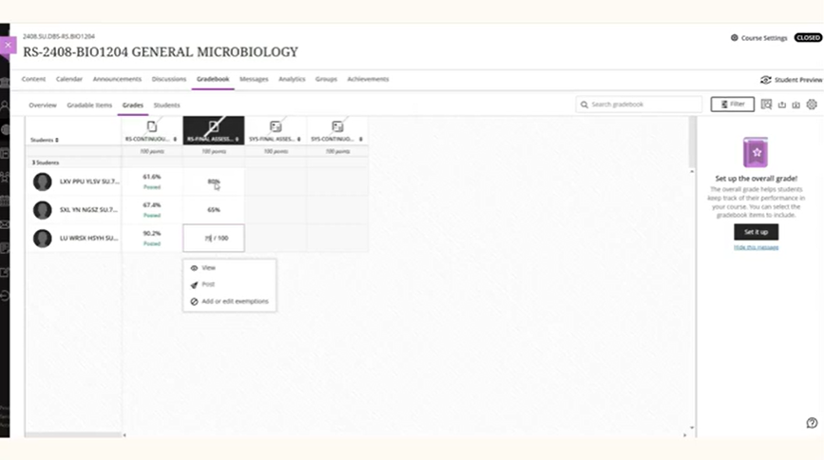

Part: Post RS Columns for All Students
Before transferring grades, make sure all RS columns are posted for all students.
To post RS columns, click the column header and select Post.
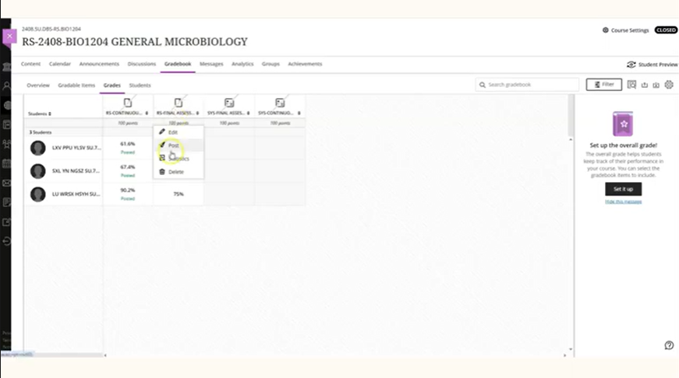
Click Post All Grades.
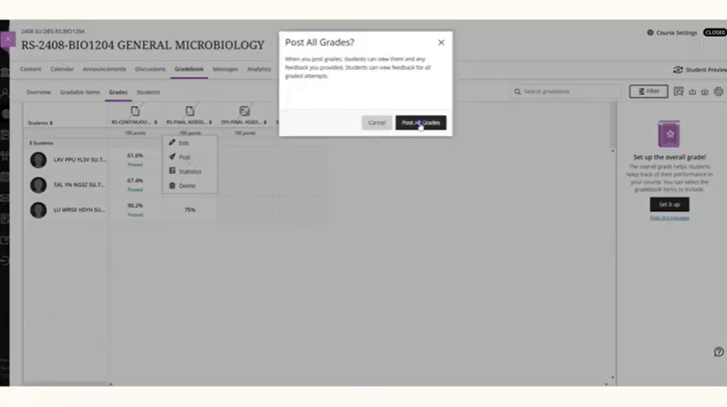

The green posted wording will appear in the grade columns.
Warning if grades are not posted, the transfer will fail.
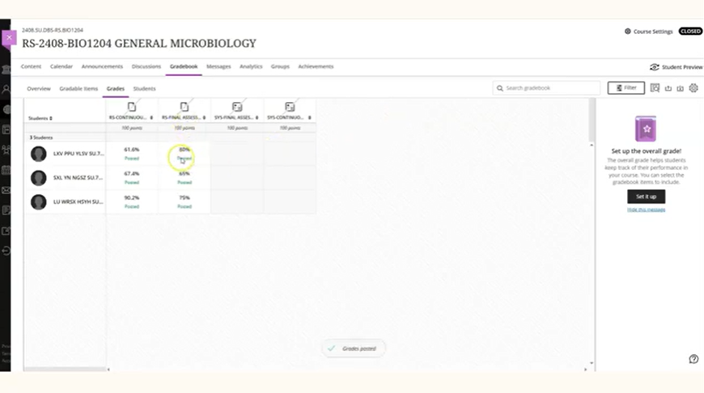

Part: Set up SYS Column
Click Edit on the relevant SYS column header to set up the SYS column.
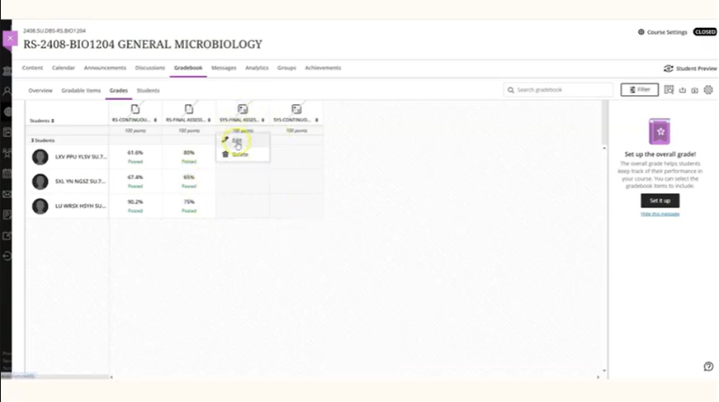
The SYS Continuous Assessment should map to the RS Continuous Assessment grade column and SYS Final Assessment to map to RS Final Assessment grade column.
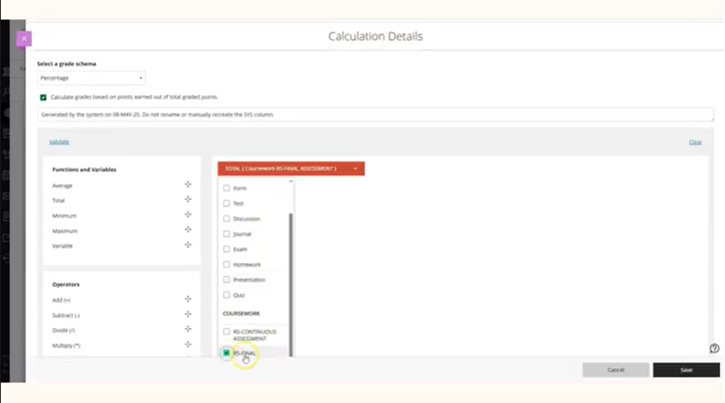

Navigate to the SYS Continuous Assessment column and click Edit. In the Total Function dropdown, select the matching RS column. Set the display to Percentage. Click Save.
A green tick will show if the expression is valid.
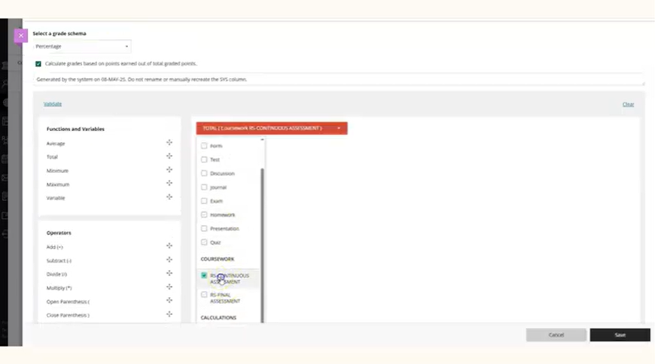
Follow the same steps to configure the SYS Final Assessment column.

Part: Grade Transfer
For transferring grades, go to Content, click on Book & Tools under the Details & Actions panel on the right.
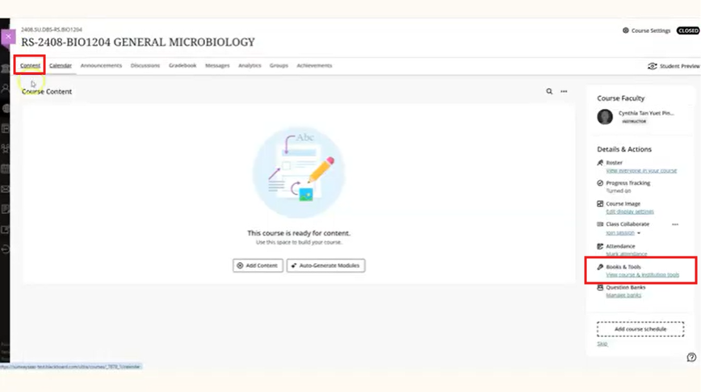
Select Grade Approval & Transfer.
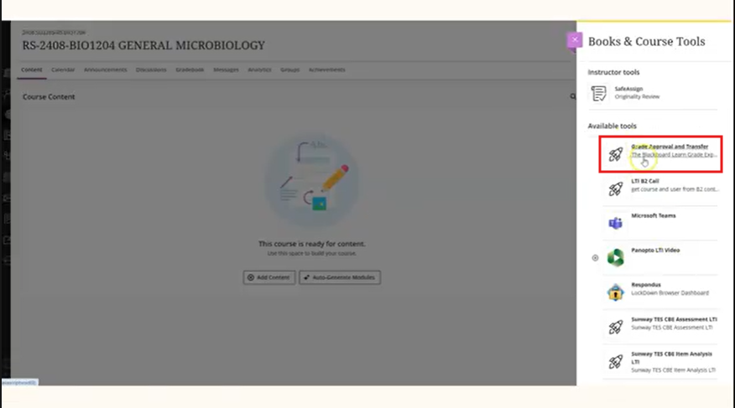

Tick the checkbox next to the course ID, click Approve Grades, then click OK to confirm.
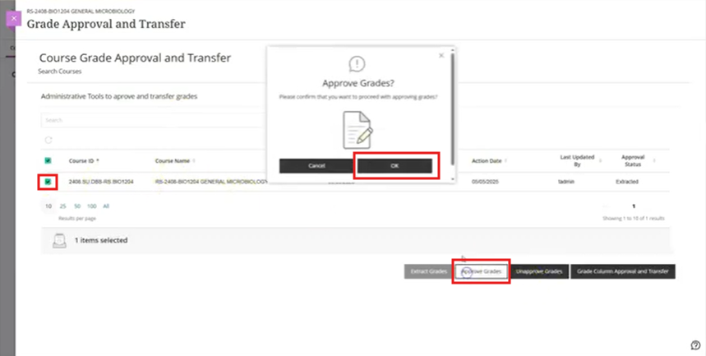
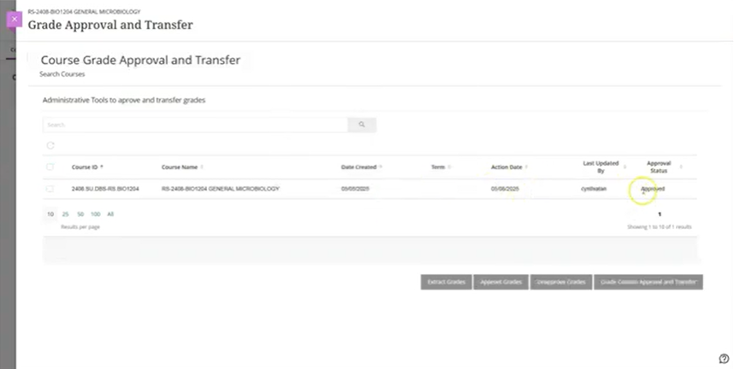

End of Guide

